Carolina Quesada Vilchez

40099828

Rama Alrifai

40116096

Be our guest

A report submitted in partial fullfilment of the requirements of SOEN-357

Concordia University

September 21, 2022

# Introduction

The Quebec Government has hired your design company to design an app to support local restaurants after the pandemic to increase their revenue and minimize the detrimental effects of the high inflation.

It is up to you and your team to determine the focus of your application and specifically what types of functionalities your application will have.

## Understand the problem

described the problem or concept and specified the major components to be examine

Selected and prioritized information appropriate for solving the problem or concept define

## Research and analysis

Evidence of market research, research of related apps, etc.

Research informs design choices

Archetype personas that make sense for the user population

Personas with clear user goals

Presentation of personas is clear, understandable, etc.

User goals align with user requirements

## User Research

Clear link between personas / journeys and user research

Add any necessary notes or content that support important design decisions you made based on user research, e.g.

Interview scripts / questions or results if used

Questionnaires

Signed ethics forms (appendix included in Moodle not on webpage)

Quotes from potential end users, etc.

# Prototypes

## User Flow / Journeys / Story Maps / User Scenario

Clear description of user actions over time

Clear understanding of users goals and opportunities

Narrative is polished and there is an effective visualization

Actors align with personas and their actions in the map are rooted in data you gathered

## Color, animation, fonts and logo

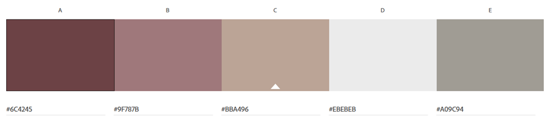

## Sketches and Wireframes

Construct proposed solutions consistent with the proposed criteria

Clear what interactions take place on each page

Components are laid out sensibly on the screen

Alignment to grid is evident; strong consideration for eye flow and eye appeal.

Someone who does not know your concept should be able to understand your website/app

## Design

Mockup is visually appealing (choice of colour, symbols, fonts, animations, etc.)

Appearance is appropriate to target users

All components have correct spelling and grammar

Font choices are appropriate for the concept

Positive and negative space considered as well as paragraph formatting

Look and feel appropriate to the target user

Usability appropriate to the target user

Organized, easy to access and user-friendly design is unified with all elements working together to create a harmonious overall appearance and enhanced user experience

## Website

## The website you’ve created is visually pleasing, easy to navigate, information is clearly presented, et

# Tools

Adobe XD

Adobe Photoshop

Microsoft Word

Adobe Acrobat

Android API

Kotlin or Java environement

HTML5

REACT

# Conclusion

Link the goal and the solution in a short summary.

**REFERENCES**

# Figures